# Baseline

RHS_Upr_OB_pickup = [538.53,351]; #RHS Upper OB pickup point

RHS_Lwr_OB_pickup = [564.85,171.5]; #RHS Lower OB pickup point

RHS_Upr_IB_pickup = [304.29,348.38]; #RHS Upper IB pickup point

RHS_Lwr_IB_pickup = [227.28,149.35]; #RHS Lower IB pickup point

static_camber = -1.5; #In degrees

UWB_length = 234.254625; #Upper wishbone length in front view

LWB_length = 418.9412262; #Lower wishbone length in front view

UWB_angle = 0.6408328324; #Upper wishbone angle to horizontal. Anti-clockwise positive

LWB_angle = -7.910191806; #Lower wishbone angle to horizontal. Anti-clockwise positive

Baseline kingpin angle is: -8.34˚.

Baseline scrub radius is: 10.0 mm.

Baseline roll centre height is: 164.46 mm.

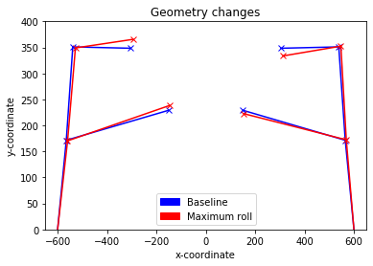

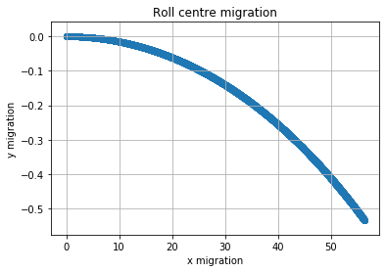

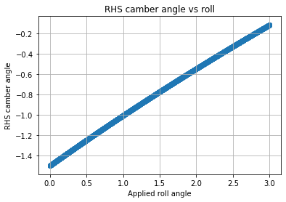

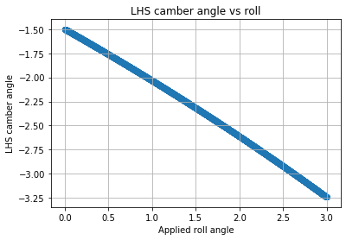

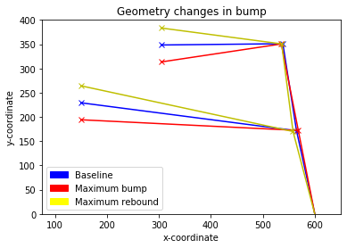

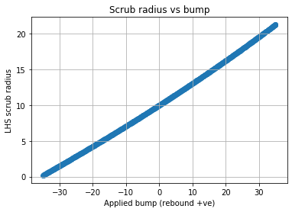

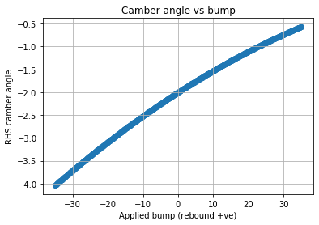

# RDW_Geom001

RHS_Upr_OB_pickup = [538.53,315]; #RHS Upper OB pickup point

RHS_Lwr_OB_pickup = [564.85,130]; #RHS Lower OB pickup point

RHS_Upr_IB_pickup = [299.98,200]; #RHS Upper IB pickup point

RHS_Lwr_IB_pickup = [215,70]; #RHS Lower IB pickup point

static_camber = -1.5; #In degrees

UWB_length = 264.8; #Upper wishbone length in front view

LWB_length = 354.94; #Lower wishbone length in front view

UWB_angle = 25.739629449782196; #Upper wishbone angle to horizontal. Anti-clockwise positive

LWB_angle = 9.732215290781069; #Lower wishbone angle to horizontal. Anti-clockwise positive

**The motivation behind this geometry was to lower the ride height to around 50-70 mm and return the baseline roll centre to a sensible position above the ground plane.**

|  |  |  |
| --- | --- | --- |
|  | **Baseline** | **New** |
| Suspension Data | Baseline kingpin angle is: -8.34˚.  Baseline scrub radius is: 10.0 mm.  Baseline roll centre height is: 164.46 mm. | Baseline kingpin angle is: -8.1˚.  Baseline scrub radius is: 16.65 mm.  Baseline roll centre height is: 18.62 mm. |
| Geometry Changes in Roll |  |  |
| Roll Centre Migration |  |  |
| RHS Camber Angle vs Roll |  |  |
| LHS Camber Angle vs Roll |  |  |
| Geometry Changes in Bump |  |  |
| Scrub Radius vs Bump |  |  |
| Camber Angle vs Bump |  |  |

## Conclusions:

* Roll centre position and migration is sensible. Lateral migration could be improved but would be acceptable.
* RHS camber changes in bump show a strange characteristic and this needs further investigation with other geometries.
* LHS camber recovery in roll is improved – but potentially “too much” as it loses out in bump.
* Camber changes in bump are much more pronounced but this is an expected result of the more aggressive geometry. It is beyond an acceptable limit and needs to be reduced.
* Scrub radius in bump is less linear but reaches a smaller peak value.

## Next steps:

* Try lengthening the upper wishbone to see the effect on camber.
* Investigate moving the OB points. Can we have a similar scrub radius and reduce the inclination of the wishbones to something more conventional?

# JDRS_Geom001

The baseline geometry is FDW_Geom001. The change in this geometry is a less aggressive angle downwards.

RHS_Upr_OB_pickup = [528,355]; #RHS Upper OB pickup point

RHS_Lwr_OB_pickup = [565,140]; #RHS Lower OB pickup point

RHS_Upr_IB_pickup = [305,290]; #RHS Upper IB pickup point

RHS_Lwr_IB_pickup = [215,110]; #RHS Lower IB pickup point

static_camber = -1.5; #In degrees

UWB_length = 234.254625; #Upper wishbone length in front view

LWB_length = 418.9412262; #Lower wishbone length in front view

UWB_angle = 0.6408328324; #Upper wishbone angle to horizontal. Anti-clockwise positive

LWB_angle = -7.910191806; #Lower wishbone angle to horizontal. Anti-clockwise positive

|  |  |  |
| --- | --- | --- |
|  | **Baseline** | **New** |
| Suspension Data | Baseline kingpin angle is: -8.1˚.  Baseline scrub radius is: 16.65 mm.  Baseline roll centre height is: 18.62 mm. | Baseline kingpin angle is: -9.59 ˚.  Baseline scrub radius is: 11.5mm  Baseline roll centre height is: 23.81mm |
| Geometry Changes in Roll |  |  |
| Roll Centre Migration |  |  |
| RHS Camber Angle vs Roll |  |  |
| LHS Camber Angle vs Roll |  |  |
| Geometry Changes in Bump |  |  |
| Scrub Radius vs Bump |  |  |
| Camber Angle vs Bump |  |  |

## Conclusion

* Camber characteristic is a bit more reasonable, with good camber recovery still
* Lower OB BJ is higher to prevent clashes
* Better characteristic in bump
* Roll centre is stable
* The downside is that ride height is not as low as we would want

## Next Steps

* Try to lower the ride height further with a more aggressive setup

# JDRS_Geom002

The baseline geometry is FDW_Geom001. The change in this geometry is a less aggressive angle downwards, but slightly more aggressive than JDRS_Geom001

RHS_Upr_OB_pickup = [528,355]; #RHS Upper OB pickup point

RHS_Lwr_OB_pickup = [565,140]; #RHS Lower OB pickup point

RHS_Upr_IB_pickup = [305,260]; #RHS Upper IB pickup point

RHS_Lwr_IB_pickup = [215,90]; #RHS Lower IB pickup point

static_camber = -1.5; #In degrees

UWB_length = X; #Upper wishbone length in front view

LWB_length = X; #Lower wishbone length in front view

UWB_angle = X; #Upper wishbone angle to horizontal. Anti-clockwise positive

LWB_angle = -X; #Lower wishbone angle to horizontal. Anti-clockwise positive

|  |  |  |
| --- | --- | --- |
|  | **Baseline** | **New** |
| Suspension Data | Baseline kingpin angle is: -8.1˚.  Baseline scrub radius is: 16.65 mm.  Baseline roll centre height is: 18.62 mm. | Baseline kingpin angle is: -9.76 ˚.  Baseline scrub radius is: 10.91mm  Baseline roll centre height is: 16.64mm |
| Geometry Changes in Roll |  |  |
| Roll Centre Migration |  |  |
| RHS Camber Angle vs Roll |  |  |
| LHS Camber Angle vs Roll |  |  |
| Geometry Changes in Bump |  |  |
| Scrub Radius vs Bump |  |  |
| Camber Angle vs Bump |  |  |

## Conclusions

* Lower ride height
* Camber recovery is great, with a normal characteristic
* Roll centre stable
* Bump characteristic is marginally better

# JDRS_Geom003

The baseline geometry is JDRS_Geom001. The change in this geometry is a slight extension of the upper wishbone

RHS_Upr_OB_pickup = [528.53,355]; #RHS Upper OB pickup point

RHS_Lwr_OB_pickup = [564.85,140]; #RHS Lower OB pickup point

RHS_Upr_IB_pickup = [300,285]; #RHS Upper IB pickup point

RHS_Lwr_IB_pickup = [215,110]; #RHS Lower IB pickup point

static_camber = -1.5; #In degrees

UWB_length = X; #Upper wishbone length in front view

LWB_length = 418.9412262; #Lower wishbone length in front view

UWB_angle = X; #Upper wishbone angle to horizontal. Anti-clockwise positive

LWB_angle = -7.910191806; #Lower wishbone angle to horizontal. Anti-clockwise positive

|  |  |  |
| --- | --- | --- |
|  | **Baseline** | **New** |
| Suspension Data | Baseline kingpin angle is: -9.59 ˚.  Baseline scrub radius is: 11.5mm  Baseline roll centre height is: 23.81mm | Baseline kingpin angle is: -9.59˚.  Baseline scrub radius is: 11.5 mm.  Baseline roll centre height is: 29.47 mm. |
| Geometry Changes in Roll |  |  |
| Roll Centre Migration |  |  |
| RHS Camber Angle vs Roll |  |  |
| LHS Camber Angle vs Roll |  |  |
| Geometry Changes in Bump |  |  |
| Scrub Radius vs Bump |  |  |
| Camber Angle vs Bump |  |  |

## Conclusion

* Camber recovery is even better
* Worse characteristic in bump.
* Would not take over JDRS_Geom002 based on the worsened bump characteristic.

# RDW_Geom002

The baseline geometry is JDRS_Geom001. This geometry is a compromise to allow the front geometry to be used with a legal chassis, with minimal modifications from FBR19.

RHS_Upr_OB_pickup = [528.53,355]; #RHS Upper OB pickup point

RHS_Lwr_OB_pickup = [564.85,140]; #RHS Lower OB pickup point

RHS_Upr_IB_pickup = [305,290]; #Create empty coordinate set for RHS Upr IB pickup point.

RHS_Lwr_IB_pickup = [215,110]; #Create empty coordinate set for RHS Lwr IB pickup point.

static_camber = -1.5; #In degrees

UWB_length = 231.442565; #Upper wishbone length in front view

LWB_length = 351.1339096; #Lower wishbone length in front view

UWB_angle = 15.02518383; #Upper wishbone angle to horizontal. Anti-clockwise positive

LWB_angle = 4.901182735; #Lower wishbone angle to horizontal. Anti-clockwise positive

|  |  |  |
| --- | --- | --- |
|  | **Baseline** | **New** |
| Suspension Data | Baseline kingpin angle is: -8.1˚.  Baseline scrub radius is: 16.65 mm.  Baseline roll centre height is: 18.62 mm. | Baseline kingpin angle is: -9.59˚.  Baseline scrub radius is: 11.5 mm.  Baseline roll centre height is: 16.35 mm. |
| Geometry Changes in Roll |  |  |
| Roll Centre Migration |  |  |
| RHS Camber Angle vs Roll |  |  |
| LHS Camber Angle vs Roll |  |  |
| Geometry Changes in Bump |  |  |
| Scrub Radius vs Bump |  |  |
| Camber Angle vs Bump |  |  |

## Conclusion

* Camber does not go positive in bump so is favourable.
* Scrub radius does not drastically change and generally stays lower.
* Good amount of camber recovery.
* Lateral roll migration, in particular, could be improved.

# RDW_Geom003

The baseline geometry is RDW_Geom002. This geometry increases the length of the lower wishbone by 5 mm to see the effect on roll migration. It will also form a useful comparison with RDW_Geom004.

RHS_Upr_OB_pickup = [528.53,355]; #RHS Upper OB pickup point

RHS_Lwr_OB_pickup = [564.85,140]; #RHS Lower OB pickup point

static_camber = -1.5; #In degrees

UWB_length = 231.442565; #Upper wishbone length in front view

LWB_length = 356.1339096; #Lower wishbone length in front view

UWB_angle = 15.02518383; #Upper wishbone angle to horizontal. Anti-clockwise positive

LWB_angle = 4.901182735; #Lower wishbone angle to horizontal. Anti-clockwise positive

|  |  |  |
| --- | --- | --- |
|  | **Baseline** | **New** |
| Suspension Data | Baseline kingpin angle is: -9.59˚.  Baseline scrub radius is: 11.5 mm.  Baseline roll centre height is: 16.35 mm. | Baseline kingpin angle is: -9.59˚.  Baseline scrub radius is: 11.5 mm.  Baseline roll centre height is: 16.35 mm. |
| Geometry Changes in Roll |  |  |
| Roll Centre Migration |  |  |
| RHS Camber Angle vs Roll |  |  |
| LHS Camber Angle vs Roll |  |  |
| Geometry Changes in Bump |  |  |
| Scrub Radius vs Bump |  |  |
| Camber Angle vs Bump |  |  |

## Conclusion

* Outside camber worse in roll.
* Vertical roll migration 10x better and lateral roll migration halved.
* Would take over RDW_Geom002

# RDW_Geom004

The baseline geometry is RDW_Geom002. This geometry increases convergence of the wishbones by 0.5° by rotating the lower wishbone clockwise.

RHS_Upr_OB_pickup = [528.53,355]; #RHS Upper OB pickup point

RHS_Lwr_OB_pickup = [564.85,140]; #RHS Lower OB pickup point

static_camber = -1.5; #In degrees

UWB_length = 231.442565; #Upper wishbone length in front view

LWB_length = 351.1339096; #Lower wishbone length in front view

UWB_angle = 15.02518383; #Upper wishbone angle to horizontal. Anti-clockwise positive

LWB_angle = 4.401182735; #Lower wishbone angle to horizontal. Anti-clockwise positive

|  |  |  |
| --- | --- | --- |
|  | **Baseline** | **New** |
| Suspension Data | Baseline kingpin angle is: -9.59˚.  Baseline scrub radius is: 11.5 mm.  Baseline roll centre height is: 16.35 mm. | Baseline kingpin angle is: -9.59˚.  Baseline scrub radius is: 11.5 mm.  Baseline roll centre height is: 24.64 mm. |
| Geometry Changes in Roll |  |  |
| Roll Centre Migration |  |  |
| RHS Camber Angle vs Roll |  |  |
| LHS Camber Angle vs Roll |  |  |
| Geometry Changes in Bump |  |  |
| Scrub Radius vs Bump |  |  |
| Camber Angle vs Bump |  |  |

## Conclusion

* Camber control in bump is slightly worse.
* Roll migration reduced ≈ 50%. Not as good as RDW_Geom003 but the curve is more “typical”.
* Camber in roll largely unchanged but maybe slightly better.
* Need to try a halfway combo of RDW_Geom003 and RDW_Geom004.

# RDW_Geom005

The baseline geometry is RDW_Geom002. This geometry is a halfway-hybrid of RDW_Geom003 and RDW_Geom004 (slightly longer, more converging lower wishbone).

RHS_Upr_OB_pickup = [528.53,355]; #RHS Upper OB pickup point

RHS_Lwr_OB_pickup = [564.85,140]; #RHS Lower OB pickup point

RHS_Upr_IB_pickup = [305, 295]; #RHS Upper IB pickup point

RHS_Lwr_IB_pickup = [212.71, 113.52]; #RHS Lower IB pickup point

static_camber = -1.5; #In degrees

UWB_length = 231.442565; #Upper wishbone length in front view

LWB_length = 353.1339096; #Lower wishbone length in front view

UWB_angle = 15.02518383; #Upper wishbone angle to horizontal. Anti-clockwise positive

LWB_angle = 4.301182735; #Lower wishbone angle to horizontal. Anti-clockwise positive

|  |  |  |
| --- | --- | --- |
|  | **Baseline** | **New** |
| Suspension Data | Baseline kingpin angle is: -9.59˚.  Baseline scrub radius is: 11.5 mm.  Baseline roll centre height is: 16.35 mm. | Baseline kingpin angle is: -9.59˚.  Baseline scrub radius is: 11.5 mm.  Baseline roll centre height is: 26.29 mm. |
| Geometry Changes in Roll |  |  |
| Roll Centre Migration |  |  |
| RHS Camber Angle vs Roll |  |  |
| LHS Camber Angle vs Roll |  |  |
| Geometry Changes in Bump |  |  |
| Scrub Radius vs Bump |  |  |
| Camber Angle vs Bump |  |  |

## Conclusion

* Camber control in bump slightly worse but negligible.
* Extremely stable roll centre.
* Camber recovery improved but, in reality, negligible.
* Scrub radius worse in rebound but nothing to be concerned by.
* If chassis suits this, it can be taken as new geometry.

**Rear Geometries**

# ﻿RDW_Geom001

RHS_Upr_OB_pickup = [528.53,310]; #RHS Upper OB pickup point

RHS_Lwr_OB_pickup = [564.85,130]; #RHS Lower OB pickup point

﻿static_camber = -1.0; #In degrees

UWB_length = 215; #Upper wishbone length in front view

LWB_length = 320; #Lower wishbone length in front view

UWB_angle = 10; #Upper wishbone angle to horizontal. Anti-clockwise positive

LWB_angle = 2; #Lower wishbone angle to horizontal. Anti-clockwise positive

|  |  |
| --- | --- |
|  | **Baseline** |
| Suspension Data | ﻿Baseline kingpin angle is: -11.41˚.  Baseline scrub radius is: 8.92 mm.  Baseline roll centre height is: 37.23 mm. |
| Geometry Changes in Roll |  |
| Roll Centre Migration |  |
| RHS Camber Angle vs Roll |  |
| LHS Camber Angle vs Roll |  |
| Geometry Changes in Bump |  |
| Scrub Radius vs Bump |  |
| Camber Angle vs Bump |  |

# RDW_Geom002

|  |  |  |
| --- | --- | --- |
|  | **Baseline** | **New** |
| Suspension Data | ﻿Baseline kingpin angle is: -11.41˚.  Baseline scrub radius is: 8.92 mm.  Baseline roll centre height is: 37.23 mm. | ﻿Baseline kingpin angle is: -11.41˚.  Baseline scrub radius is: 8.92 mm.  Baseline roll centre height is: 37.23 mm. |
| Geometry Changes in Roll |  |  |
| Roll Centre Migration |  |  |
| RHS Camber Angle vs Roll |  |  |
| LHS Camber Angle vs Roll |  |  |
| Geometry Changes in Bump |  |  |
| Scrub Radius vs Bump |  |  |
| Camber Angle vs Bump |  |  |